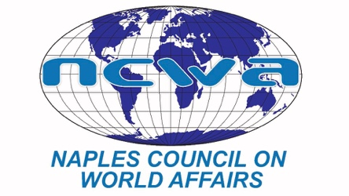
www.ncwa-fl.org
FOR IMMEDIATE RELEASE: February, 2023
For information, contact: Carol Green, VP/Operations
carolgreen2@mac.com or (303)886-6531
Or
Jim Schmotter, President
jimschmotter@twc.com
(607) 882-1960

NAPLES COUNCIL ON WORLD AFFAIRS
BRINGS FOREIGN POLICY EXPERTS TO SW FLORIDA

The stalwart – and amazingly effective – defense by Ukrainians of their company in the face of invasion a year ago by Russia has captured the minds and hearts of most Americans. We have watched in amazement as the armed forces of Ukraine have defended their country and taken back areas previously occupied by Russia. Ukrainian president, Volodymyr Zelensky, has reminded us that this is ultimately a battle between democracy and autocracy, and his argument has caught the attention of Americans everywhere.
The vital issues involved in Ukraine’s battle have been driven home in Naples through the Naples Council on World Affairs (NCWA), a 1,600-member nonprofit organization founded in 1980 that brings insightful information about foreign affairs to our community through its lecture season and its 26 Great Decisions discussion groups.
In a recent presentation, Michael O’Hanlon, a senior fellow and director of research for the foreign policy program at the Brookings Institution, weighed the risks of nuclear engagement between Russia and the U.S. and its NATO allies and concluded that the U.S. should supply sophisticated heavy tanks to Ukraine to support ending the war as soon as possible. (Within days of his talk in Naples, the U.S. announced it would supply 31 tanks and other sophisticated armament, and, after behind the scenes talks with the U.S. and other allies of Ukraine, Germany overcame its hesitancy and announced it would supply tanks, as well).
National security analyst Joe Ciricione, a member of the Council on Foreign Relations, evaluated the risks of Russia striking first with its array of nuclear arms and argued that Russia had too much to lose to do so. Ian Brzezinski, a senior fellow at the Atlantic Council’s Scowcroft Center on Strategy and Security, weighed the potential impact if the U.S. faces increased engagement from both Russia and China at the same time.
Bernard Cole and Dr. Cynthia Watson, professors emeritus at the National War College, delved into China’s increasing signs of aggression over Taiwan and the South China Sea, and the U.S. response in building its sphere of influence in the Indo-Pacific.
Upcoming NCWA speakers will focus on the U.S. Relationship with Mexico; Food Insecurity in the wake of Russia’s invasion of Ukraine,; and the New World Order that may be evolving. NCWA’s Great Decisions groups are following a parallel course in exploring the issues raised in the lecture program.
In addition to its lectures and Great Decisions discussion groups, NCWA on February 24 at the Naples Hilton will sponsor a biennial event for its members, a full day of lectures and discussions on defense strategy by experts from the National War College.
NCWA also has ongoing outreach programs to schools in Southwest Florida in which it provides scholarships in foreign affairs for summer study by high school students, testing of student knowledge about current events through competitions, and organizes a Model United Nations program for high school students in Collier and Lee Counties at Florida Gulf Coast University (this year on March 6 and 7).
NCWA membership enrollment is now available for the next season at www.ncwa-fl.org.

##

