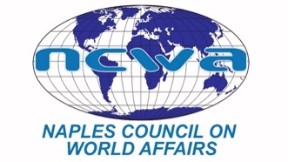
www.NCWA-fl.org

April 13, 2022

FOR IMMEDIATE RELEASE:
Contact:
Carol Green
Communications Chair
carolgreen2@mac.com
(303)886-6531

Gulf Coast High School Teams Win Top Two Places in Academic World Quest

Teams from Gulf Coast High School placed first and second in the annual High School Academic World Quest (AWQ) held recently at the Community School of Naples. Third place was won by Barron Collier High school.

The first-place team from Gulf Coast High School will be flown to Washington DC to compete in the national competition on April 29-30. AWQ is a fast-paced team competition that tests students’ knowledge of politics, geography, global economics, history and world cultures.

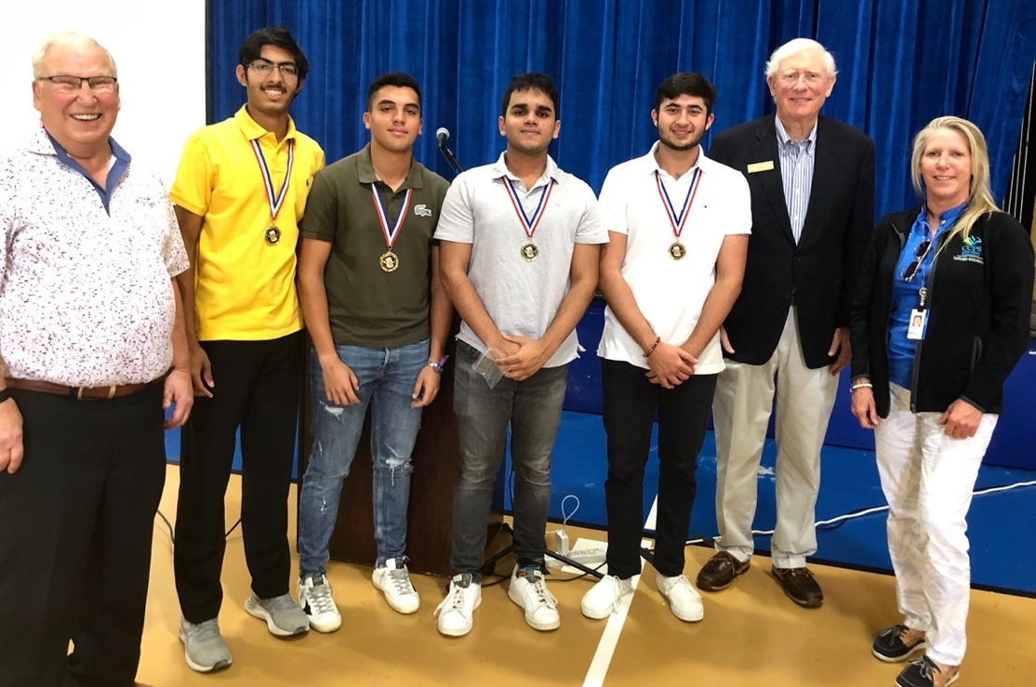
First place winner was the team from Gulf Coast High School. From left are Mark Walchak, NCWA School Outreach chair; Bharath Ram, Manuel Hernandez, Davansh Barve, Zayn Dalao, Jim Schmotter, NCWA president, and Mikie Stroh of Collier County Public Schools.

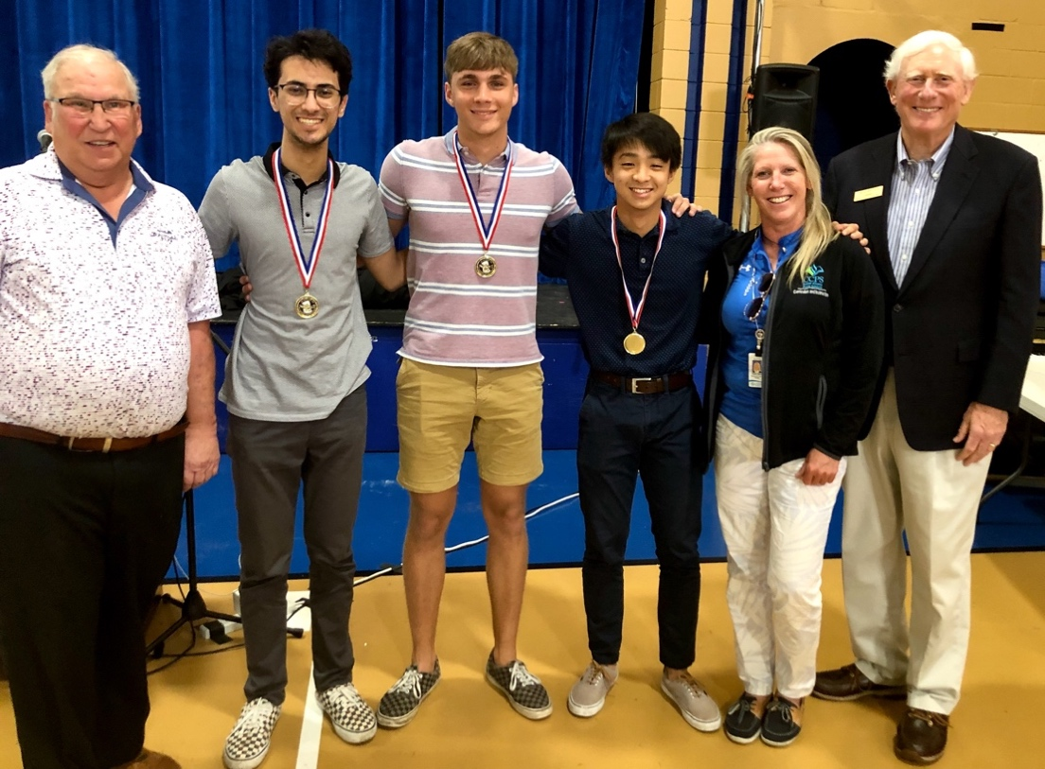
Another team from Gulf Coast High School placed second. From left are Mark Walchak, NCWA School Outreach chair; John Bekhash, Aiden Starchbein, Doung Tran, Mikie Stroh of Collier County Schools, and Jim Schmotter, NCWA president.

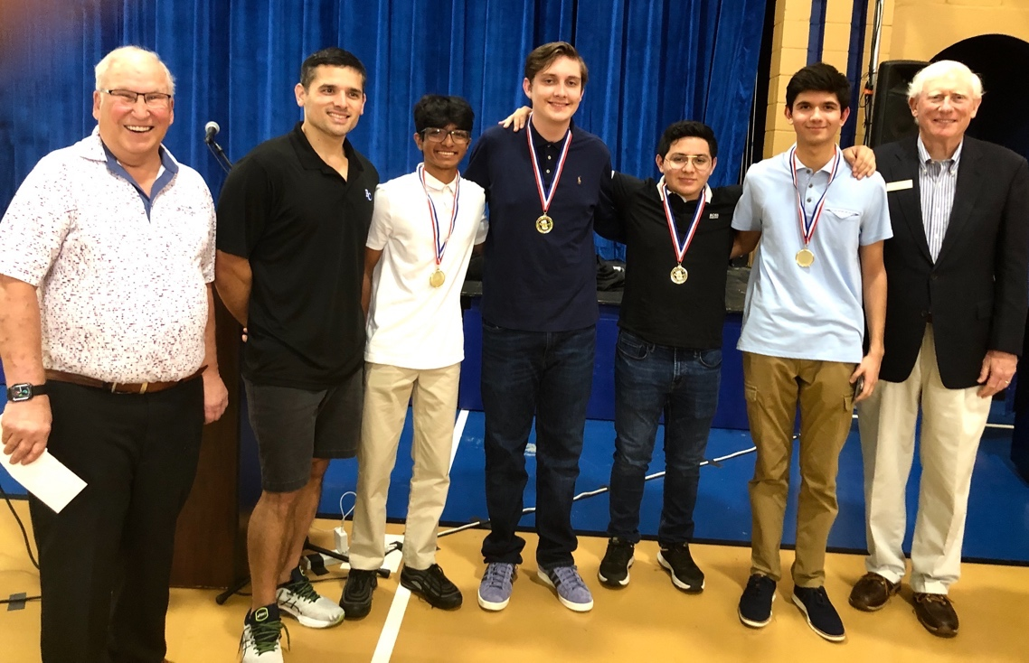
Barron Collier High School’s team placed third. From left are Mark Walchak, NCWA School Outreach chair; Nicholas Danyo, coach; Darshan Dadlani, Eric Japson, Chris Garcia, Fred Terezi, and Jim Schmotter, NCWA president.

###

